LECTURE-5
BIG DATA AND ANALYTICS

TOPICS
- Introduction
- Data Types
- Charaterstics of Big Data
- Data Sources
- Data Acquistion
- Data Storage
- Big Data Analytics for Industry.4.0

- Introduction
Big Data Analytics: Big data analytics involves the collection, storage, and analysis of large volumes of data to uncover patterns, trends, and insights. It utilizes advanced algorithms and machine learning techniques to process and derive actionable information from diverse data sources generated by machines, sensors, and other digital systems.

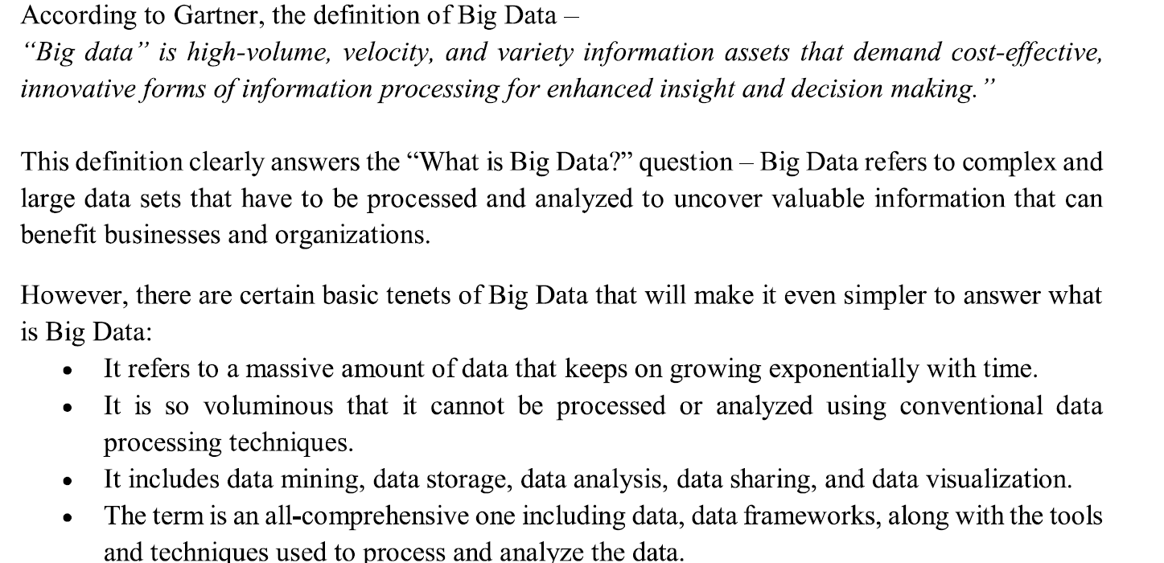

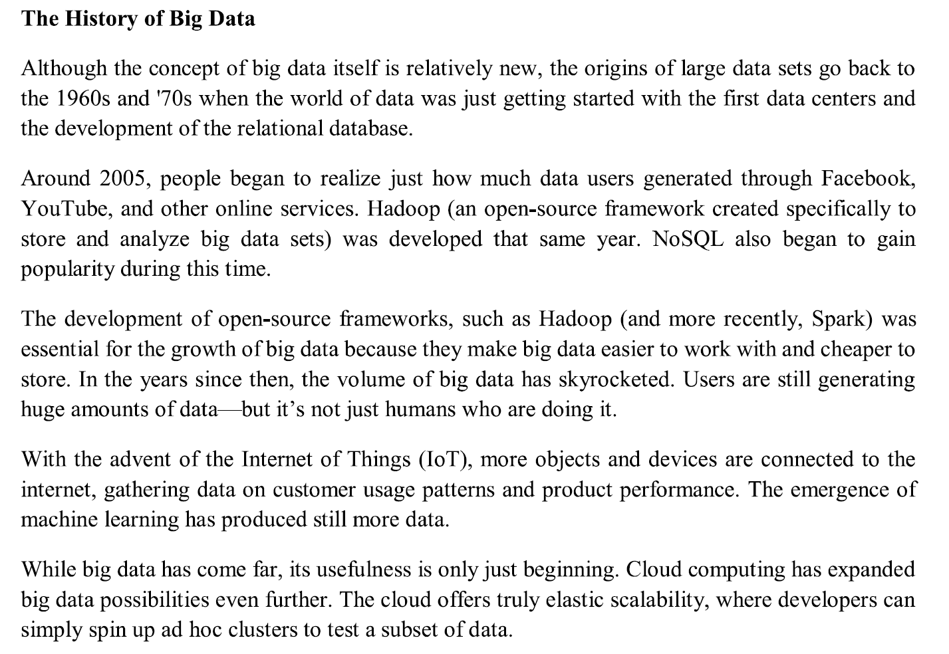

- Data Types

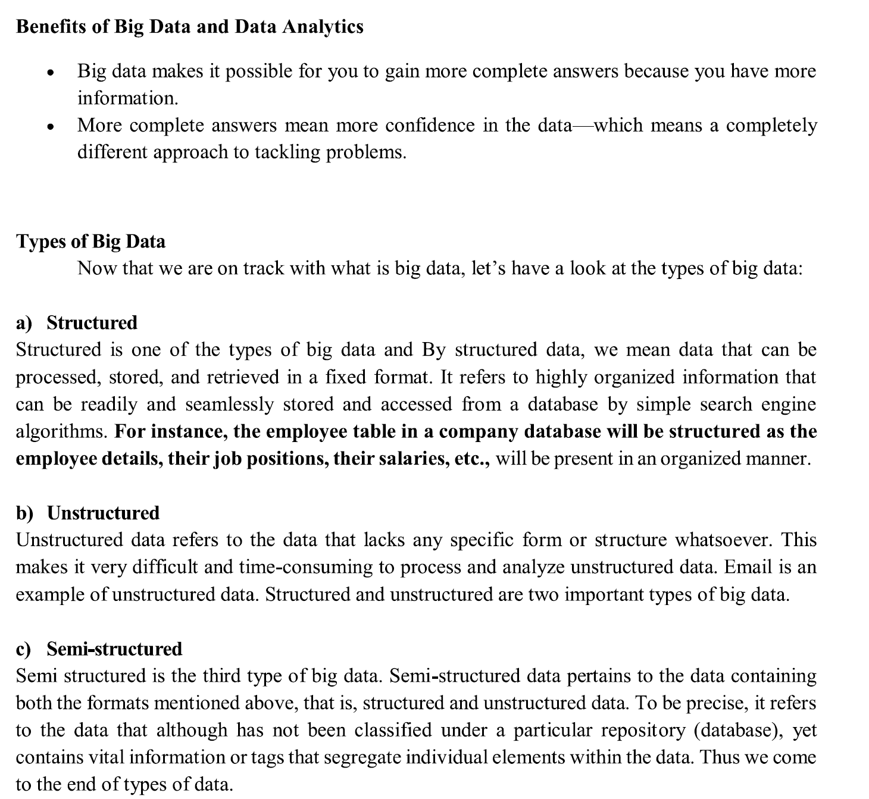

- Charaterstics of Big Data

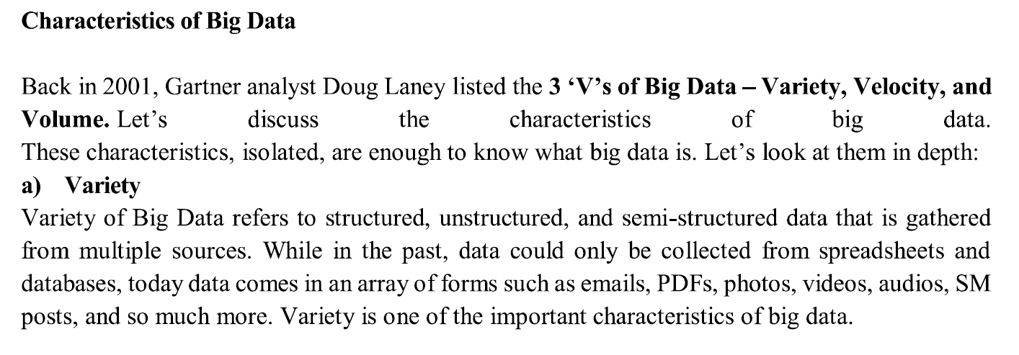
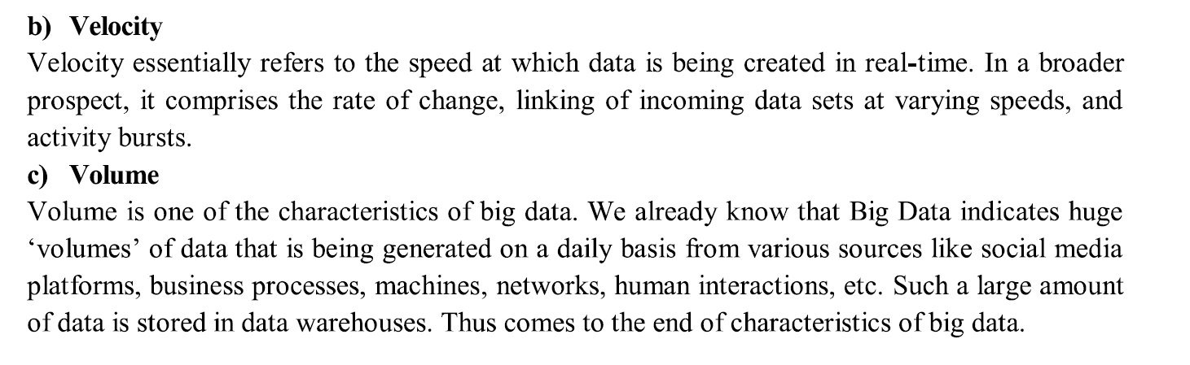
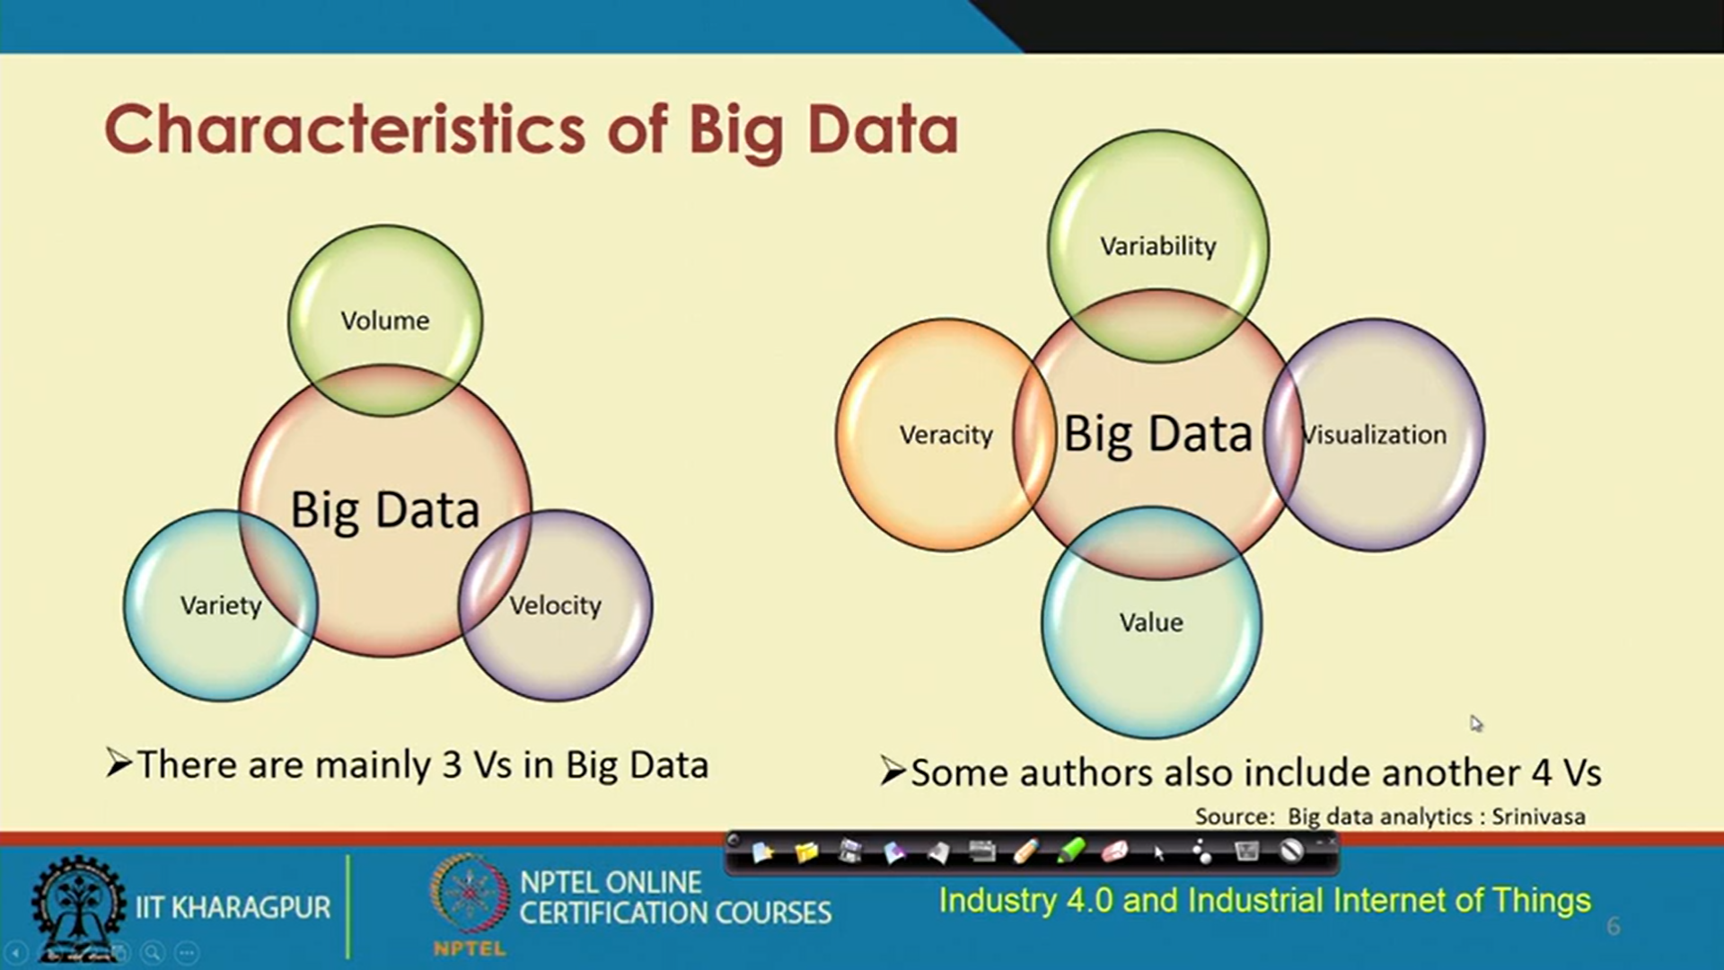

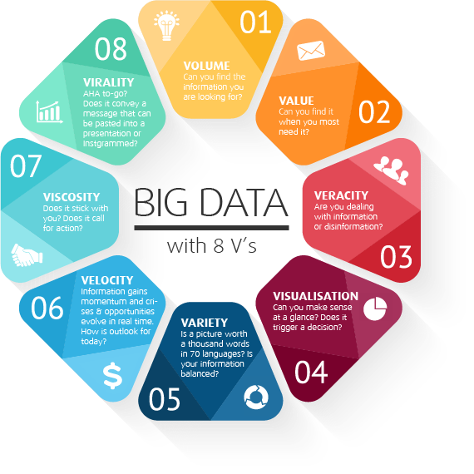
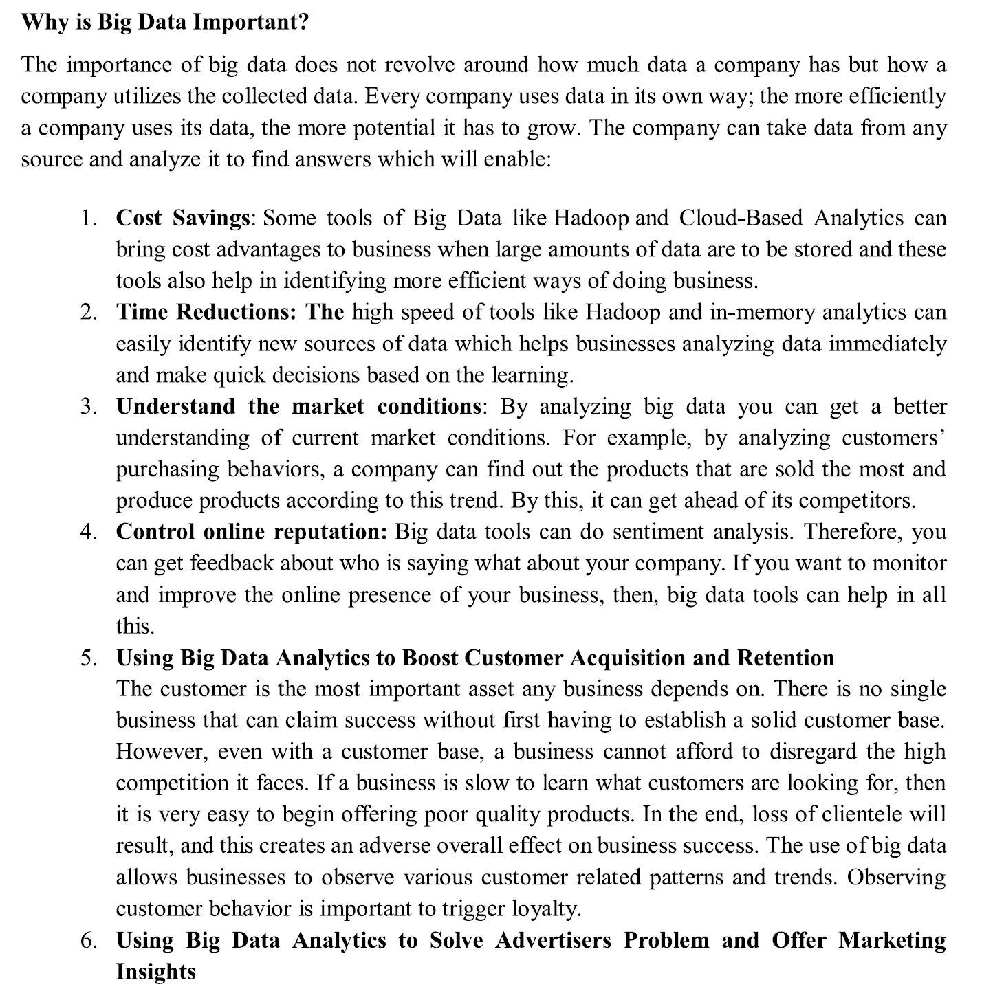
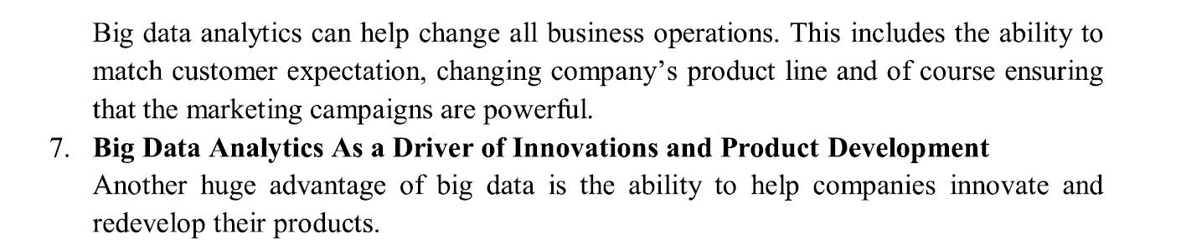

Sources of big data
Main sources of big data can be grouped under the headings of social (human), machine (sensor) and transactional.
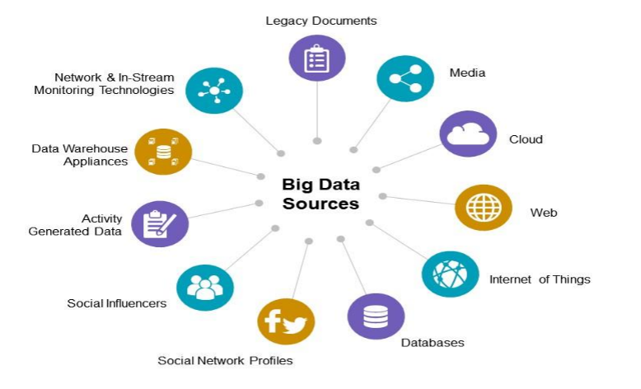
Social Networks (human-sourced information): – this source is becoming more and more relevant to organisations. This source includes all social media posts, videos posted etc.(this information is the record of human experiences, previously recorded in books and works of art, and later in photographs, audio and video. Human-sourced information is now almost entirely digitized and stored everywhere from personal computers to social networks. Data are loosely structured and often ungoverned. )
Internet of Things (machine-generated data):– this data comes from what can be measured by the equipment used.: The phenomenal growth in the number of sensors and machines used to measure and record the events and situations in the physical world. The output of these sensors is machine-generated data, and from simple sensor records to complex computer logs, it is well structured. As sensors proliferate and data volumes grow, it is becoming an increasingly important component of the information stored and processed by many businesses. Its well-structured nature is suitable for computer processing, but its size and speed is beyond traditional approaches. Data from sensors,Fixed sensors,Home automation , Weather/pollution sensors,Traffic Scientific sensors .Security/surveillance videos/images,Mobile sensors (tracking) ,Mobile phone location ,Cars, Satellite images ,. Data from computer systems, Web logs
Traditional Business systems (process-mediated data):– these processes record and monitor business events of interest, such as registering a customer, manufacturing a product, taking an order, etc. The process-mediated data thus collected is highly structured and includes transactions,reference tables and relationships, as well as the metadata that sets its context. Traditional business data is the vast majority of what IT managed and processed, in both operational and BI systems. Usually structured and stored in relational database systems. (Some sources belonging to this class may fall into the category of Administrative data,Data produced by Public Agencies , Medical records,Data produced by businesses ,Commercial transactions ,Banking/stock records ,E-commerce ,Credit cards)

- Data Acquistion(COLLECTION,TRANSMISSION,PREPROCESSING,)

Data acquisition has been understood as the process of gathering, filtering, and cleaning data before the data is put in a data warehouse or any other storage solution. The acquisition of big data is most commonly governed by four of the Vs: volume, velocity, variety, and value.There are four methods of acquiring data: collecting new data; converting/transforming legacy data; sharing/exchanging data; and purchasing data. It is a preprocessing before the data is put in a data warehouse or any other storage solution. . Most data acquisition scenarios assume high-volume, high-velocity, high-variety, but low-value data, making it important to have adaptable and time-efficient gathering, filtering, and cleaning algorithms that ensure that only the high-value fragments of the data are actually processed by the data-warehouse analysis.

Big Data architecture has to acquire high speed data from a variety of sources like web, DBMS(OLTP), NoSQL, HDFS and the data is also diverse in nature . It is required to store only data which could be helpful or “raw” data with a lower degree of uncertainty[1]. For that a filter could be established. In some applications, the conditions of generation of data are important, thus it could be interesting for further analysis to capture these metadata and store them with the corresponding data
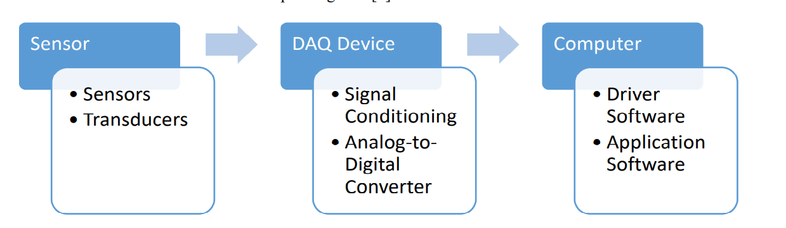
- Protocols that enable the gathering of information from distributed data sources
- Frameworks through which the data is collected by using different protocols
- Technologies that allow constant storage of data acquired through the frameworks

Frameworks and tech for data gathering
Data gathering frameworks and technologies are very specific when it comes to their functionalities and ideal usage, so it’s important to define your overall goals before you lock- in on any of them.When it comes to data gathering, some of the most widely used frameworks and technologies are:

Storm
Storm is an open-source framework for robust distributed real-time computation on streams of data. It supports a wide range of programming languages and storage facilities, and one of its main advantages is that it can be utilized in many data gathering scenarios including stream processing and distributed RPC for solving intensive functions on-the-fly.“It’s used by a number of big systems, with some of the largest ones being Groupon, The Weather Channel and Twitter.”

Simply Scalable Streaming System
Simply Scalable Streaming System or S4 is a distributed, general-purpose platform for developing applications that process streams of data which was launched by Yahoo! Inc. It is designed to work on commodity hardware, avoiding I/O bottlenecks by relying on an all-in- memory approach.“provides a simple programming interface for processing data streams in a decentralized, symmetric, and pluggable architecture”.

Kafka
Kafka is a distributed publish-subscribe messaging system designed to support persistent messaging with high-throughput. It aims to unify offline and online processing with its ability to partition real-time consumption over a cluster of machines, and is built in a way that minimizes the network overhead and sequential disk operations.“It was originally developed at LinkedIn to track the huge volume of activity events generated by the website.”

Flume
Flume is a service whose purpose is to provide a distributed, reliable and available system for efficiently collecting, aggregating and moving large amounts of log data from many different sources to a centralized data store. Its architecture is based on streaming data flows — it is simple and flexible, but also robust and fault tolerant with tuneable reliability mechanisms and many failover and recovery mechanisms.“Flume was designed with these four key goals in mind — reliability, scalability, manageability and extensibility.”

Hadoop
Hadoop is an open-source project that focuses on developing a framework for reliable, scalable, and distributed computing on big data using clusters of commodity hardware.“It’s used and supported by a large number of big organizations like Facebook, AOL, Baidu, IBM, Imageshack, and Yahoo.”
- Big Data Storage
Every month, more companies are adopting it to help them improve their businesses. But with any new technology comes challenges and questions, and big data is no exception.
The first challenge is how much storage you'll need for your extensive data system. If you're going to store large amounts of information about your customers and their behavior, you'll need a lot of space for that data to live.
Companies are constantly gathering new types of information about their customer's habits and preferences, and they're looking at ways they can use this information to improve their products or services.
As a result, big data systems will continue growing exponentially until something stops them. It means it's essential for companies who want to use this technology effectively to plan how they'll deal with it later on down the road when it becomes too much for them alone!
- Big Data Storage Key Considerations
Big data storage is a complicated problem. There are many things to consider when building the infrastructure for your big data project, but there are three key considerations you must consider before you move forward.
- Data velocity: Your data must be able to move quickly between processing centers and databases for it to be helpful in real-time applications.
- Scalability: The system should be able to expand as your business does and accommodate new projects as needed without disrupting existing workflows or causing any downtime.
- Cost efficiency: Because big data projects can be so expensive, choosing a system that reduces costs without sacrificing the quality of service or functionality is essential and how long you want your stored data to remain accessible
- Key Insights for Big Data Storage
Big data storage is a critical part of any business. The sheer volume of data being created and stored by companies is staggering and growing daily. But without a proper strategy for storing and protecting this data, your business could be vulnerable to hackers—and your bottom line could suffer.So storage methods are one of major key factor
- Data Storage Methods
Warehouse and cloud storage are two of the most popular options for storing big data. Warehouse storage is typically done on-site, while cloud storage involves storing your data offsite in a secure location.

Warehouse Storage
Warehouse storage is one of the more common ways to store large amounts of data, but it has drawbacks. For example, if you need immediate access to your data and want to avoid delays or problems accessing it over the internet, there might be better options than this. Also, warehouse storage can be expensive if you're looking for long-term contracts or need extra personnel to manage your warehouse space.

Cloud Storage
Cloud storage is an increasingly popular option since it's easier than ever to use this method, thanks to advancements in technology such as Amazon Web Services (AWS). With AWS, you can store unlimited data without worrying about how much space each file takes up on their servers. They'll automatically compress them before sending them over, so they take up less space overall!

Data Storage Technologies
Apache Hadoop, Apache HBase, and Snowflake are three big data storage technologies often used in the data lake analytics paradigm.

Hadoop
Hadoop has gained considerable attention as it is one of the most common frameworks to support big data analytics. A distributed processing framework based on open-source software, Hadoop enables large data sets to be processed across clusters of computers. Large data sets were initially intended to be processed and stored across clusters of commodity hardware.

HBase
With HBase, you can use a NoSQL database or complement Hadoop with a column-oriented store. This database is designed to efficiently manage large tables with billions of rows and millions of columns. The performance can be tuned by adjusting memory usage, the number of servers, block size, and other settings.

Snowflake
Snowflake for Data Lake Analytics is an enterprise-grade cloud platform for advanced analytics applications built on top of Apache Hadoop. It offers real-time access to historical and streaming data from any source and format at any scale without requiring changes to existing applications or workflows. It also enables users to quickly scale up their processing power as needed without having to worry about infrastructure management tasks such as provisioning and

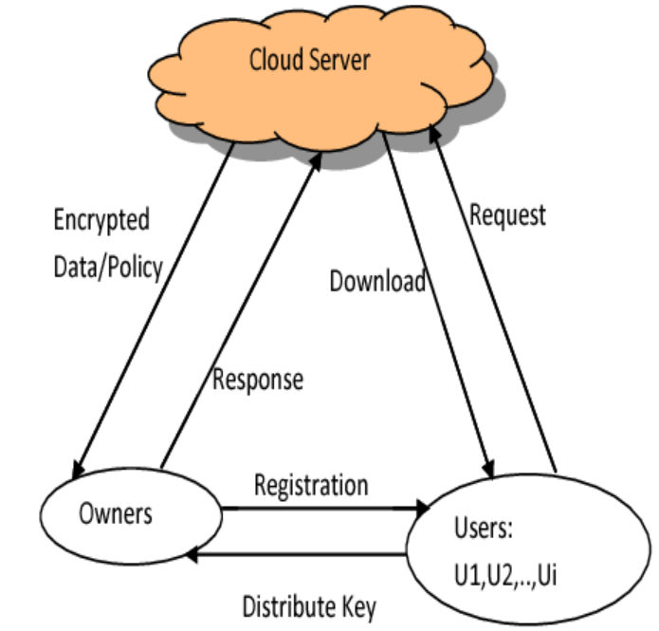
(Big Data Storage solutions)

Specifics of each of these Big Data Storage methods reveals:
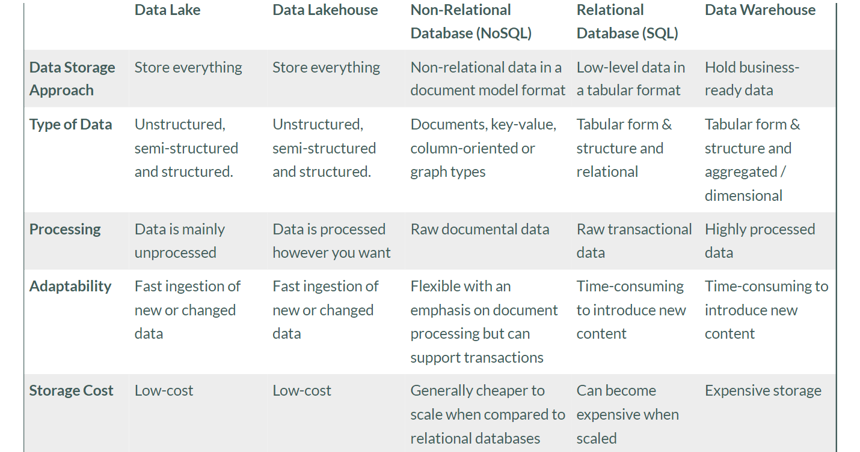
- Big Data Analytics for Industry.4.0
Big data analytics
Some data are irrelevant or relevant for system and users.So to increase the accuracy and efficiency utilization data taken from huge amount should be analyze .Big data analytics is the use of advanced computing technologies on huge data sets to discover valuable correlations, patterns, trends, and preferences for companies to make better decisions. In Industry 4.0, big data analytics plays a role in a few areas including in smart factories, where sensor data from production machinery is analyzed to predict when maintenance and repair operations will be needed. Through application of it, manufacturers experience production efficiency, understand their real-time data with self-service systems, predictive maintenance optimization, and production management automation.
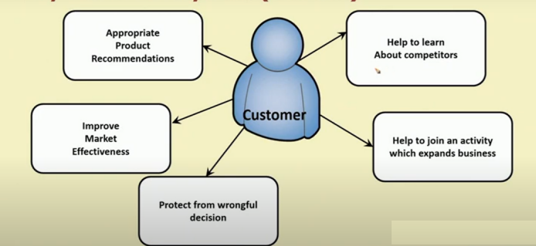

Analytical techniques include predictive modeling, machine learning, simulation, process optimization and control along with business intelligence tools. However, performing analytics through an all-inclusive technology can be time-consuming and expensive. The infographic below showcases different analytical techniques used to generate manufacturing insights.

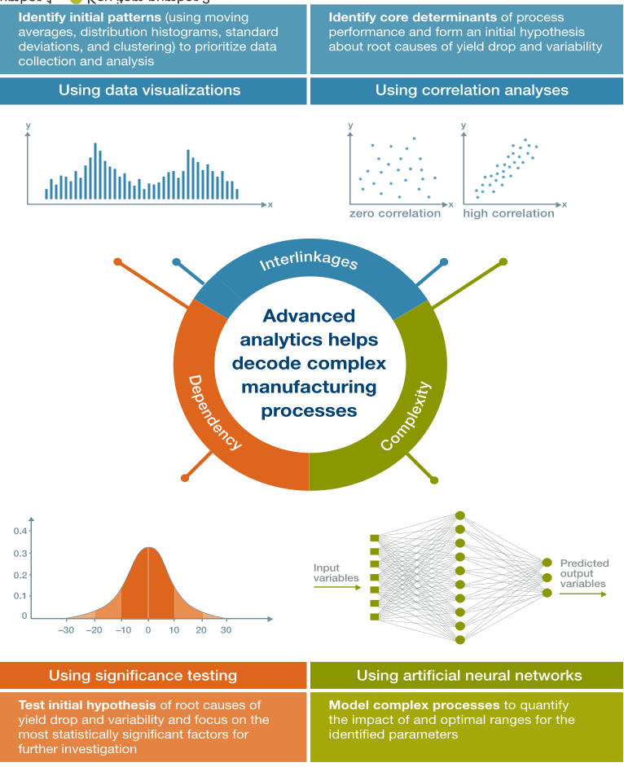

- Use of big data analytics in business
Businesses use big data analytics to improve business decisions by understand patterns and picking up on trends from huge amounts of customer data.

Big data analytics used in Industry 4.0
Manufacturers use big data analytics in the same way as most other commercial entities except with a narrower focus. They collect huge amounts of data from smart sensors through cloud computing and IIoT platforms that allow them to uncover patterns that help them improve the efficiency of supply chain management.
Big data analytics can help them discover hidden variables causing bottlenecks in production that they didn’t even know existed. After identifying the source of the problem, manufacturers use targeted data analytics to better understand the underlying cause of bottleneck variables. This helps manufacturers improve output while reducing cost and eliminating waste.
Production efficiency and assets are everything the manufacturing industry. The manufacturers’ ability to maintain their means of production and keep schedules tight and on track can mean the difference between a good reputation and a bad one. Big data analytics reduces breakdowns and unscheduled downtime by about 25 percent.
Big data analytics is crucial to real-time performance, supply chain optimization, price optimization, fault prediction, product development, and smart factory design.

There are four main types of big data analytics that support and inform different business decisions.

1 Descriptive analytics
Descriptive analytics refers to data that can be easily read and interpreted. This data helps create reports and visualize information that can detail company profits and sales.
Example: During the pandemic, a leading pharmaceuticals company conducted data analysis on its offices and research labs. Descriptive analytics helped them identify unutilized spaces and departments that were consolidated, saving the company millions of dollars.

2. Diagnostics analytics
Diagnostics analytics helps companies understand why a problem occurred. Big data technologies and tools allow users to mine and recover data that helps dissect an issue and prevent it from happening in the future.
Example: A clothing company’s sales have decreased even though customers continue to add items to their shopping carts. Diagnostics analytics helped to understand that the payment page was not working properly for a few weeks.

3. Predictive analytics
Predictive analytics looks at past and present data to make predictions. With artificial intelligence (AI), machine learning, and data mining, users can analyze the data to predict market trends.
Example: In the manufacturing sector, companies can use algorithms based on historical data to predict if or when a piece of equipment will malfunction or break down.

4. Prescriptive analytics
Prescriptive analytics provides a solution to a problem, relying on AI and machine learning to gather data and use it for risk management.
Example: Within the energy sector, utility companies, gas producers, and pipeline owners identify factors that affect the price of oil and gas in order to hedge risks.
Otherway methods for BIG DATA ANALYSIS can be represented as
- Association rule learning
- Classification tree analysis
- Genetic algorithms
- Machine learning
- Regression analysis
- Sentiment analysis
- Social network analysis

Tools used in big data analytics
Various technology has advanced so that there are many intuitive software systems available for data analysts to use.
- Hadoop: An open-source framework that stores and processes big data sets. Hadoop is able to handle and analyze structured and unstructured data.
- Spark: An open-source cluster computing framework used for real-time processing and analyzing data.
- Data integration software: Programs that allow big data to be streamlined across different platforms, such as MongoDB, Apache, Hadoop, and Amazon EMR.
- Stream analytics tools: Systems that filter, aggregate, and analyze data that might be stored in different platforms and formats, such as Kafka.
- Distributed storage: Databases that can split data across multiple servers and have the capability to identify lost or corrupt data, such as Cassandra.
- Predictive analytics hardware and software: Systems that process large amounts of complex data, using machine learning and algorithms to predict future outcomes, such as fraud detection, marketing, and risk assessments.
- Data mining tools: Programs that allow users to search within structured and unstructured big data.
- NoSQL databases: Non-relational data management systems ideal for dealing with raw and unstructured data.
- Data warehouses: Storage for large amounts of data collected from many different sources, typically using predefined schemas.

